Caffeine: A Little Goes a Long Way

Part 1: Equal Proportions and Graphing

The Story. For today’s lab, you will do research and produce a graph to compare the caffeine content of several drinks. You will have 1.5 class periods to complete this portion of the project.

Step 1. Name a new spreadsheet “2017_12 Caffeine” and share it with crosa@mountpisgahschool.org

Step 2. Set up your spreadsheet like the example at the end of these instructions. Choose 7 seven caffeine-containing drinks to research. You may use the ones listed in the example if you’d like. Note that there are two columns that contain the names of the drinks. The reason for both columns is a limitation of Google Sheets; the second column needs to be included to create your graph.

Step 3. Name a new Google Doc “2017_12 Caffeine Sandbox.”

Step 4. On the internet, do some research to find the caffeine content in milligrams (mg) of each drink. To do your Internet search, use the website www.kiddle.co. If you start your search field with “caffeine content of …” you should be able to find all the information you need. Use your new Google Doc, “2017_12 Caffeine Sandbox,” to record data and enter citation information for every website you use in MLA8 format. Use the Purdue OWL for proper formatting.

For each drink find:

- The number of milligrams (mg) of caffeine

- The size of the container for which the data is reported. Make sure that you note the size of the container accurately. The size of the container could be given in ounces or milliliters. If your data is in ounces, you should convert that value to milliliters (mL). Simply multiply the volume given in ounces by 29.57 to get milliliters.

Again, all container sizes need to be in milliliters (mL). They don’t have to be the same size of container since you’re going to write a formula to “normalize” the containers based upon your “base” size in Step 5. Remember, normalizing is the process of comparing relationships of caffeine to volume where the volume of each container is the same (e.g. 250 mL). That’s how we can see which beverages have more caffeine than others.

Step 5. Enter your data that you have just found into the appropriate columns of your spreadsheet. If your spreadsheet is set up like mine, this will be in columns B and C.

Step 6. Write a formula to reflect the value of your normalized container size into column E (in my example, the formula is =$B$1). Using a formula allows you to change the container size in one cell rather than all 7 cells. Look at the figure to see how the result should be.

Step 7. Convert the number of milligrams of caffeine so you can compare amounts among the same size of container. For example, if your research showed that Mountain Dew has 54 mg of caffeine in a 355 mL bottle, it would have 38 mg of caffeine in a 250 mL container. Use a cross product formula to calculate the new values. In the example below, the formula is =B3*$B$1/C3 and it goes into cells E3:E8. Go ahead and program it in. If you write the formula correctly, you should be able to use the drag-and-copy feature to get it into all the cells.

Step 9. Using a formula in Sheets, calculate the average value for each column. For example, if you want to find the average value of the number in cells E3 through E8, use this formula:

=AVERAGE(E3:E8)

Step 10. Create a column chart of the data calculated in column E. Use Mr. Petitto’s video if you need a refresher on inserting charts in Google Sheets.

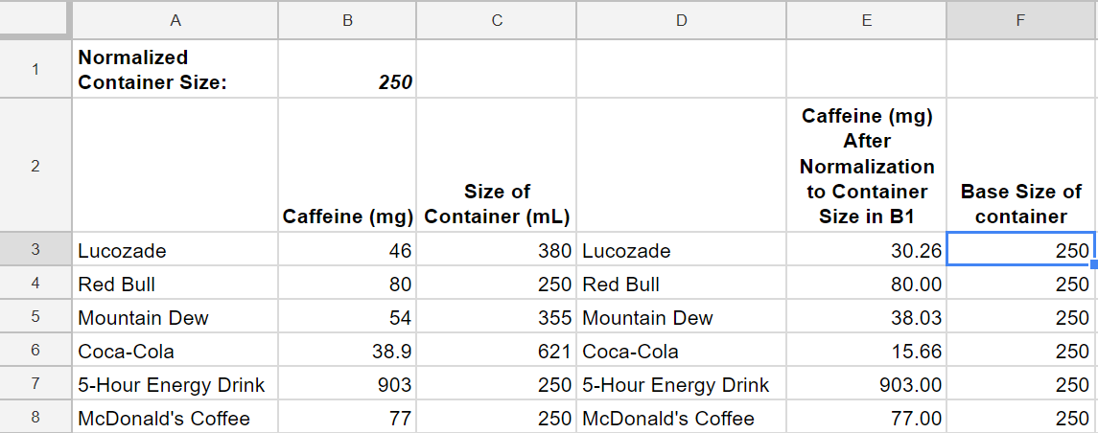

Part 2: Poster

For the second half of this three-day activity, you will work in a small group to create an eye-catching digital poster displaying the combined results of your team’s caffeine data. At a minimum, you should also include statistics on safe caffeine consumption amounts for children and adults. Use Kiddle.co to find data on caffeine recommendations. You may use the technology tool(s) of your choice (Google Doc or Slides, Glogster, Sway, etc.) to create this artifact. All sources should be cited either on the poster or in a separate Google Doc with a link on the poster. A sample poster using sugar consumption can be viewed here. This should be used as an idea of the expectation of the amount of information displayed. Your poster will look different.

Before you begin working on your poster, everyone in your group will review the elements of design found here. Use these ideas to influence your final product. In addition, follow these visual literacy guidelines:
- Use only one font type and ensure that it is clearly visible to viewers in the back of the room.
- Use contrasting colors. Avoid “rainbow” backgrounds and font colors.
- Images should only be pictures you take or those from either www.pixabay.com or www.photosforclass.com. When considering adding images, remember that “less is more.”

