Comprehensive Instructional Design Plan: Caffeine
Leeann Denham
University of West Georgia
My Client
Mrs. Christine Rosa, middle school math teacher
crosa@mountpisgahschool.org
Georgia PSC #: 1359560

The Instructional Problem
Mrs. Rosa currently teaches Algebra 1 to 8th graders. She would like to enhance her lesson on graphing proportions by adding a computer lab with real-world applications. She didn’t want to change her instruction of the content but was interested in adding a new component enriched through visual literacy, both within the teaching of the lesson and the assessment of student understanding. We landed on the topic through anecdotal evidence at middle school sporting events: a rise in the number of energy drinks in the hands of students and adults. This topic will also serve as an example to students of the everyday use of math in nearly every career from advertising, marketing, retail sales, engineering and so on.
After a brief presentation to get them started, including an infographic displaying information about caffeine consumption, the students will follow an instruction sheet leading to a graph of caffeine content in 7 different caffeine-containing drinks. Students will convert the data to equal proportions so that valid comparisons can be made on a column chart. In small groups, students will subsequently create an digital poster of their combined data in a new graph.
My artifacts will include a brief introductory Powerpoint (Appendix A), an infographic displaying information about caffeine consumption (Appendix B), and a sample poster using sugar instead of caffeine (Appendix C). To create this step-by-step lesson, we will use Gagne’s instructional model.
The Instructional Model
Robert Gagne’s step-by-step set of directives based on information processing with a focus on intellectual skills is the framework Mrs. Rosa and I have decided to employ to design this lesson. The structure and organization of Gagne’s prescribed nine steps lends itself to teaching numerous units, especially those that are procedural in nature.
- Gaining attention: The hook will be a one-minute video commercial advertising the energy drink, Lucozade. The product marketers claim that Lucozade will help you “find your flow” in miraculous, outrageous ways.
- Informing the Learner of the Objectives: Students will learn that their goal is to find data regarding caffeine content in several drinks, perform the conversion required to compare the caffeine amounts, and present the information in a visual display (part one is individual, part two is in a small group).
- Stimulating recall of prior learning: Students learned about proportions and displaying information graphically in a prior lesson. In this lesson, they will have to apply that knowledge in a real-world context and apply design elements to increase the effectiveness of their work.
- Presenting the stimulus: Students will see examples of caffeine amounts in “normalized” container sizes for several energy drinks in the introductory Powerpoint. After the Powerpoint, they will be given the handout for the self-directed lab which will require them to use www.kiddle.co to perform searches for caffeine content information.
- Providing learning guidance: At the end of each day of this 3-day lesson, there will be an opportunity for a few students to present the status of their work. Inevitably, other students will respond with “Oh! That’s how you do that!”
- Eliciting performance: The daily in-process student presentations will allow for feedback as well as idea inspiration for other students.
- Providing feedback: The teacher will interact with the students throughout this project, providing individual and whole group feedback.
- Assessing performance: Students will tweak their work based on feedback. The 3-day lesson will be assessed through a rubric.
- Enhancing retention and transfer: Part two of this lesson requires work in small groups. Their creation of a poster of combined student data, along with some statistics regarding recommended caffeine consumption amounts for children and adults with the appropriate use of images, will increase the likelihood of mastery of graphing proportions.
Description of the Lesson
This lesson is intended to fulfill the following student objectives:
- The student will calculate equivalent ratios.
- Working individually, the student will graph proportional relationships from the calculated ratios.
- In a small group, the student will design and create a meaningful poster incorporating elements of design such as line, space, and color.
- The student will practice the ethical use of materials.
- The student will work collaboratively in a small group.
The lesson will open with Mrs. Rosa showing students an advertisement for the European energy drink, Lucozade. This visual and auditory experience will hook students into the topic to be explored. The teacher will then show the “Caffeine Safety” infographic I created for a brief but poignant explanation of the reality of caffeine use (Appendix B). The previous two visuals are housed in the Powerpoint (Appendix A). The subsequent slide is the introduction to the tasks students will be undertaking. The teacher will show 6 caffeine-containing drinks along with the amount of caffeine in each. The next step is to create equivalent proportions (taught in a prior lesson - the intent for this lesson is to apply that skill to a real-world application as well as to assess their learning of that skill) so that the caffeine content can be easily compared. Students will then be given the instructions for the 3-day lab (Appendix D). Students will be given 1.5 class periods for each of the tasks. First, they will individually research caffeine content of drinks of their choice, “normalize” the proportions, and graph their results. On days two and three, students will work in small groups to create a digital poster using the technology of their choice. They will be given a link to my assignment 1 from this class (MEDT 7490) as an overview of the elements of design. In addition, I have created a sample poster using sugar instead of caffeine which will also be available to them (Appendix C). Following the elements of design such as line, space, and color, the poster should contain at a minimum a graph of a selection of their researched drinks as well as recommended caffeine consumption amounts for children and adults. Each group will be given two minutes for a mini-presentation of their work at the end of day three.
Methods of Assessment / Evaluation
The final products are the individual student graphs of caffeine data and the small group poster. Both products will be shared with the teacher through Google sheets so that she can assess student understanding of the objectives. The teacher will assess the entire project using the rubric below which includes the evaluation of products as well as her own observation of the students working.

Rubric for Caffeine Content Project
Standard | Advanced = 4 | Proficient = 3 | Basic = 2 | Novice = 1 | Score
Mathematical precision (calculating and graphing proportions) | Correct formulas were used and all calculations were accurate. | There were a few small errors in the use of formulas or calculations. | A few mathematical errors affected the final calculations. | The final products were flawed due to the student’s difficulty using math.
Collaboration | The student contributed, did his or her best work, and worked respectfully. | For the most part, the student made good use of his or her time and resources and worked well together. | The student didn’t do their part or interacted in inappropriate ways (e.g. “bossy” or impolite). | The student was disagreeable and didn’t work with the group resulting in an individual product.
Elements of design such as line, space, and color | The student used multiple elements of design to make his or her work the best possible. | The work showed evidence of the use of some elements of design. | The work showed evidence of one design element. | The work had to be explained because of the lack of design elements.
Ethical use of media. | The student cited all sources used in correct MLA8 format. | The student cited all sources used with minimal errors in their MLA8 formatting. | The student cited most sources with errors in their MLA8 formatting. | The student did not cite their sources.
Presentation | The presentation was organized, and clear, so that the audience could easily connect to the design. | The presentation was good with a clear sequence and accurate information for the audience. | A lack of some clarity resulted in questions on the steps that were followed and the information used. | A lack of planning resulted in a presentation that was difficult to follow.
 |  |  |  | Total Score:

Visual Literacy Analysis of Artifacts
The dual coding theory, giving a learner information in two different media (auditory, text, images, video, etc.), is important for instructional designers to consider to enhance learning. Infographics are a great way to incorporate text along with color, shapes, and images. Since Mrs. Rosa wanted a quick way to convey the background of the lesson, an infographic was a good solution. I created it in Canva using a combination of colors that work well together while respecting contrast to render text and images readily legible. In addition, I was careful to leave important “white space” while ensuring font size was as large as possible. The purpose of the infographic is to quickly convey that perhaps too much caffeine is a bad thing. Since I wanted to be sure students honed in on the relevant information, I referred back to Mayer’s (2014) principles of coherence, signaling, and spatial contiguity to ensure the best possible results.
The Powerpoint carries the same color theme as the infographic. The main slide of the lesson is one that introduces 6 different caffeinated drinks along with their caffeine amounts. Through a series of clicks, it also shows some of the quantities being “normalized” so that all caffeine amounts can be compared from drink to drink. The images are all clear and show enough to the audience for immediate recognition. They are arranged on the page to be as balanced as possible. The text stays true to the chosen color palette. There are no more images and there is no more text than is absolutely necessary. There are sound effects, intended to be played at a very low volume, to aid the teacher when clicking through all the information on the slide. There are different sounds to act as guides to the presenter for what just appeared on the slide. While understanding Hagen and Golombisky’s (2013) recommendation that such sound effects be used sparingly, in this case the noise aids in instruction. Finally, sources of media are cited in the presentation to model for students the proper ethical use of information.
In addition to highlighting visual literacy in the teacher presentation, students will also be required to produce an online poster. An example of the basic expectation of the poster can be found here. While the main focus of this lesson is not visual literacy skills, students will consider the elements of design as described here.
Standards: ACRL Visual and Literacy Competency
Standard 6: The visually literate student designs and creates meaningful images and visual media.
Standard 7: The visually literate student understands many of the ethical, legal, social, and economic issues surrounding the creation and use of images and visual media, and accesses and uses visual materials ethically.
Standards: Georgia Standards of Excellence
MGSE8.EE.5 Graph proportional relationships, interpreting the unit rate as the slope of the graph. Compare two different proportional relationships represented in different ways.
Reflection
Since math is not a subject I’ve taught, I was a bit wary of venturing into this topic for my final project. In the end, when I realized the desire was to incorporate real-world application as well as products that require visual literacy skills (from both me and the students), I embraced the challenge. Designing for another teacher, especially with the background information having already been taught, was not without its trials. For example, I was unsure at first how much detail was needed in the teacher presentation. Also, there was a learning curve on my end to understand exactly what was expected of the students. Delineating precisely what instructional materials were needed and understanding the student objectives in this technology-rich environment took some time. Creating the infographic was a fairly straight-forward process once I knew what information Mrs. Rosa wanted to use to introduce the topic. However, the main Powerpoint slide, the one detailing the caffeine content of six different drinks, was a bit more time consuming. Capitalizing on the combined strengths of Mrs. Rosa and myself has resulted in instructional materials that I believe will increase student engagement and learning.

References
Best Ads Channel. (2015). Lucozade energy: Find your flow. Retrieved from
https://www.youtube.com/watch?v=_IR7jL4EnCE
Diehl. (2007). Mountain Dew. Creative Commons Attribution 2.0 generic retrieved from https://creativecommons.org/licenses/by/2.0/. Cropped image retrieved from https://www.flickr.com/photos/metal4rock/2051466443/in/photolist-6m1Spw-ikaBAA-aNtDsc-aESFjV-4LFceL-94sxbp-5Z63Cd-e4SSdH-bjZkh7-ahTUMW-6fGm5X-bjZkh9-5B1K-6qyPuk-9UQfS7-bgMioK-8RFimC-a4bzT-r2sKGD-byBTZp-9aYShg-fRN69-2XPKb-5TTksn-6cr8j9-bk6Bho-9SZCL2-rVamEr-a2wkEZ-2Xi1C-9DaTvm-6oU8XM-6oUak2-2XPKT-9wxPqg-5Y1cFp-9DaSHy-PmooW-Qaa8f-5T7Pa-4YBY3X-4k1av6-p1XLE-6yAwDE-4YBY44-48hiv6
Golombisky, K., & Hagen, R. (2013). White space is not your enemy: A beginner's guide to communicating visually through graphic, web & multimedia design. 2nd edition, Boston, MA: Focal Press.
Hattwig, D., Burgess, J., Bussert, K., and Medaille, A. (2011). ACRL Visual Literacy Standards for Higher Education. http://www.ala.org/acrl/standards/visualliteracy.
Mayer, R. (2014). Multimedia instruction. In J.M Spector et al. (eds.), Handbook of research on educational communications and technology (pp. 385-399). New York: Springer Science+Business Media
Mozart, M. (2014). 5-hour energy. Creative Commons Attribution 2.0 generic retrieved from https://creativecommons.org/licenses/by/2.0/. Cropped image retrieved from https://www.flickr.com/photos/jeepersmedia/14535978930/in/photolist-o9uG7o-oqXNEL-osKfjr-oTcV1s-osKhhV-orScDj-nPQeoA-o9uQ44-oqM8Dm-jZfEAi-osKicF-oqH3Mc-o9uPEt-oqHauR-oqH71X-oqXUmL-o9uGVN-ooXwnG-osKhav-oqXVzs-oqXT6j-oazLr7-oqZhE4-oqM8xQ-osKbmM-o9uxq5-nPQXVi-oqH8Ce-oqXHyd-o9uGD5-o9uEgZ-oazPJv-orSdCy-oqXNwE-oqM6Zj-oqXJcN-osKbVH-o9uQqr-o9uyD7-o9uCmN-o9uAML-oazQfF-oqGVtK-oqZd6V-osKgqz-dQcsHD-oazyrY-oqM8RA-oqGVh2-ooXuT9
Whatley, J. (2009). You know, you’d think I’d get these for free [5-hour energy]. Creative Commons Attribution 2.0 generic retrieved from https://creativecommons.org/licenses /by/2.0/. Cropped image retrieved from https://www.flickr.com/photos/whatleydude /3681514354/in/photolist-6BjHXq-6CuVA7-6CbVX6-6uYM8B-6uYM4P-6C6Sna-6C7au4-6uYMa4-6uYMgT-6v3WXh-6uYMnD-6v3WFh-6v3WRf-6R3kAL-6v3WGU-6CbnqE-6v3WYS-6C3Dai-6CaYdN-6C7dRx-8UcMei-6uYMdV-6UE6JQ-d9xoJ-6Gp987-6HPUh3-6UA3wa-dKLH8L-6DBkL9-6DABx9-6UrUGL-6Yri7K-6Us4AA-6UnZZi-6UnTqz-bEzM4s-6UnA2r-SUv3xD-612kqT-6YsDmQ-6UrXpo-6UnAxD-6UnTTB-6UrD9W-6UnR3x-6EknYr-6DN77o-6Cw5aA-6FYUks-6UnUHc

Appendix A
The Powerpoint

Slide 1: The “hook” – a video advertising the energy drink, Lucozade.
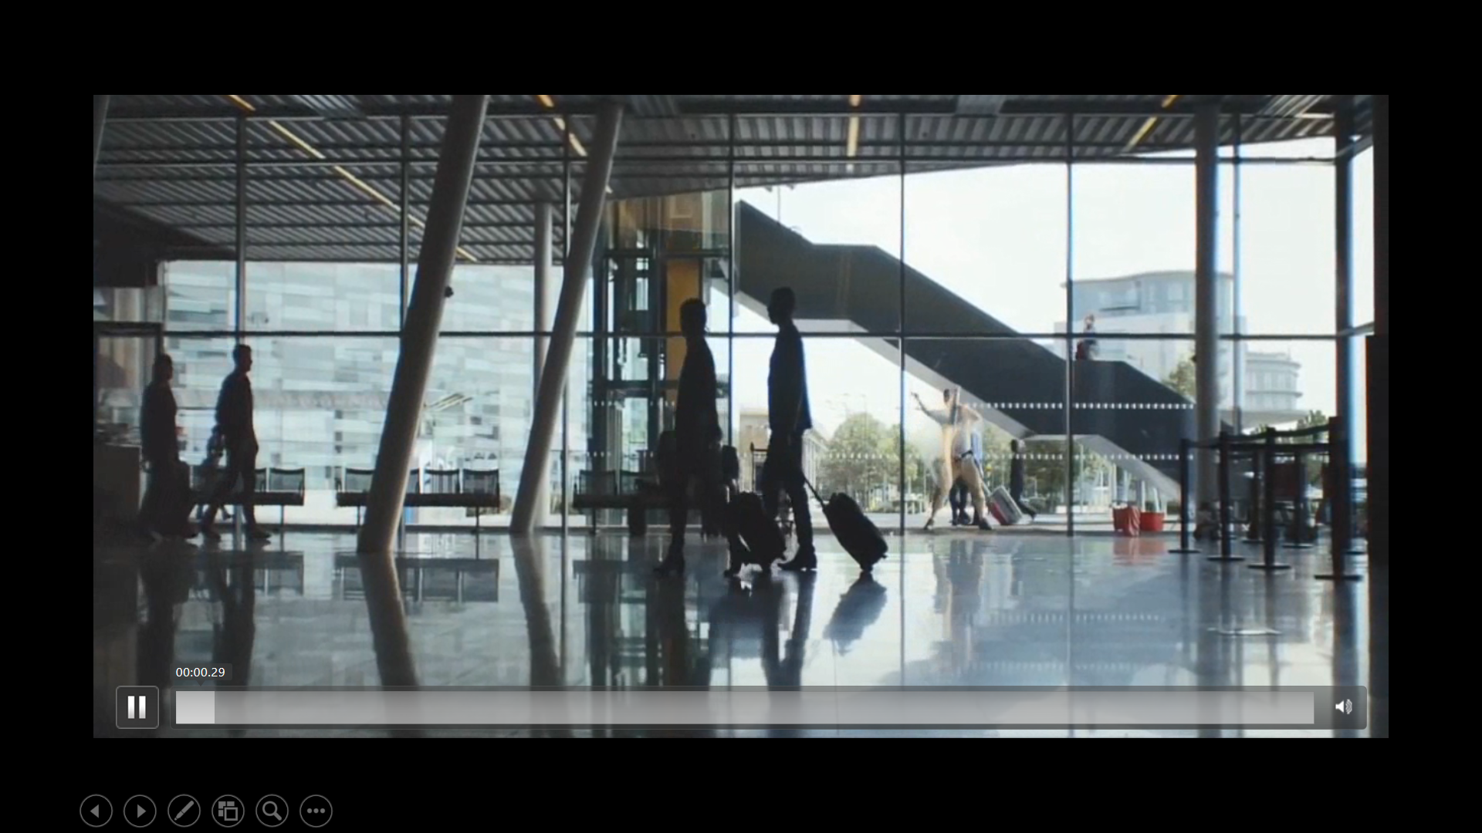

Slide 2: A link to the infographic on caffeine safety:
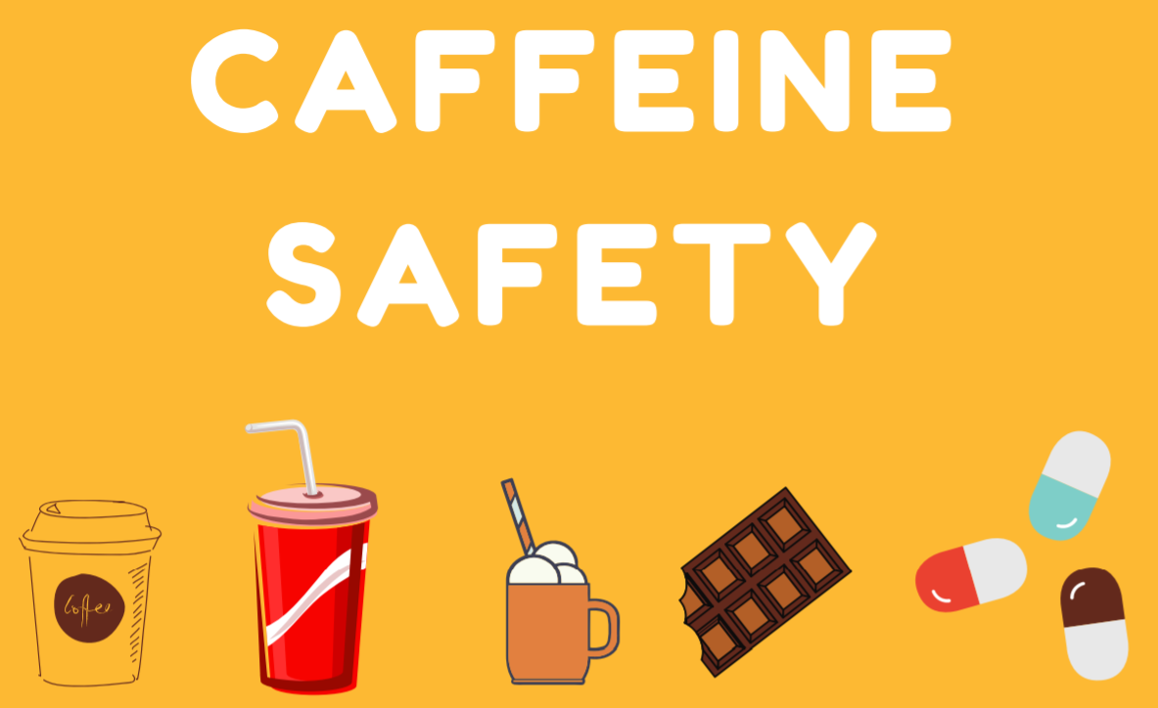
Slide 3: Teacher discussion on caffeine amounts and normalizing the container size:
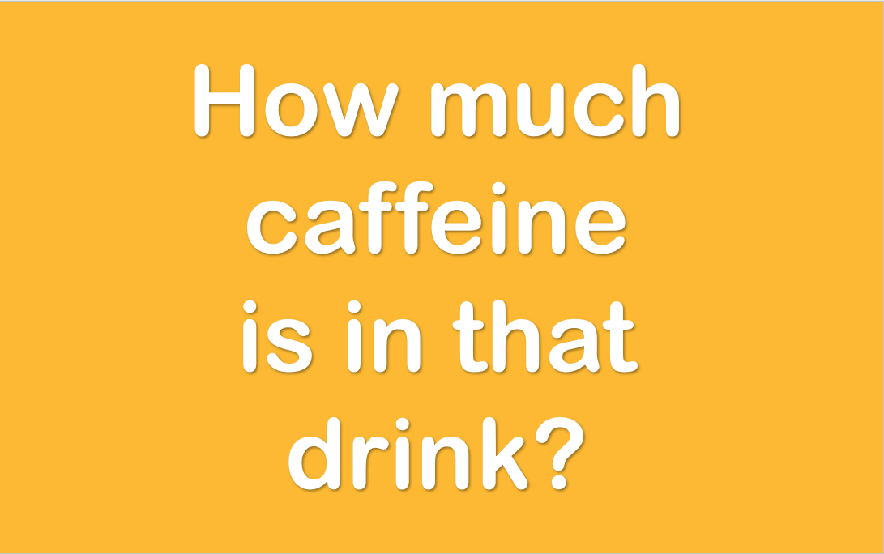

Slide 4: Show some example caffeine amounts and the importance of normalizing container size:
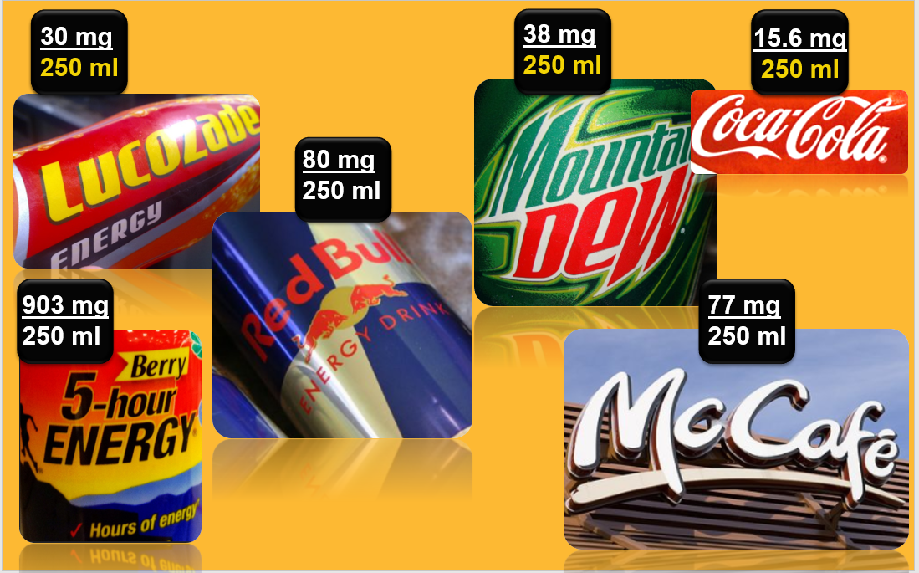
Slides 5, 6 and 7: Wrap-up slides including works cited (MLA8):
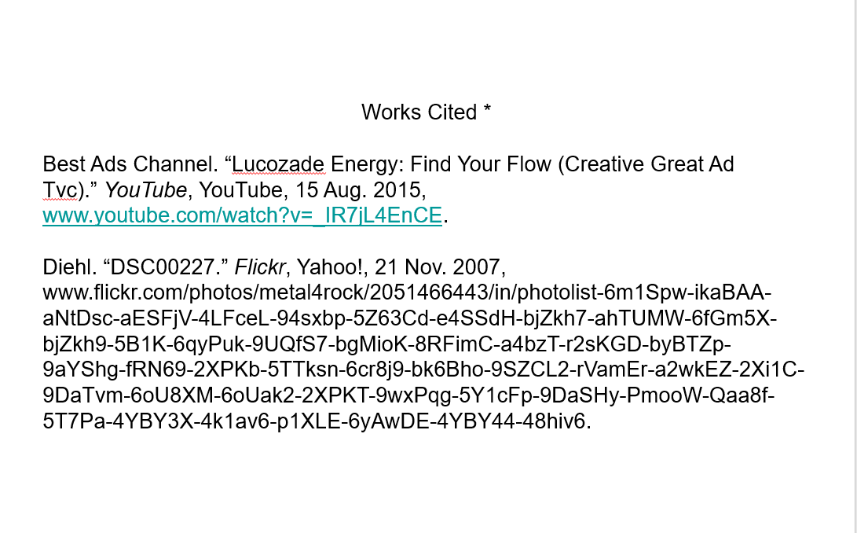
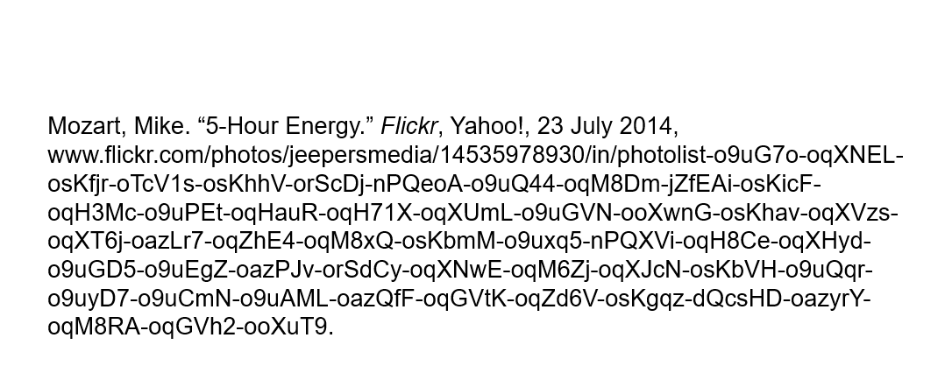
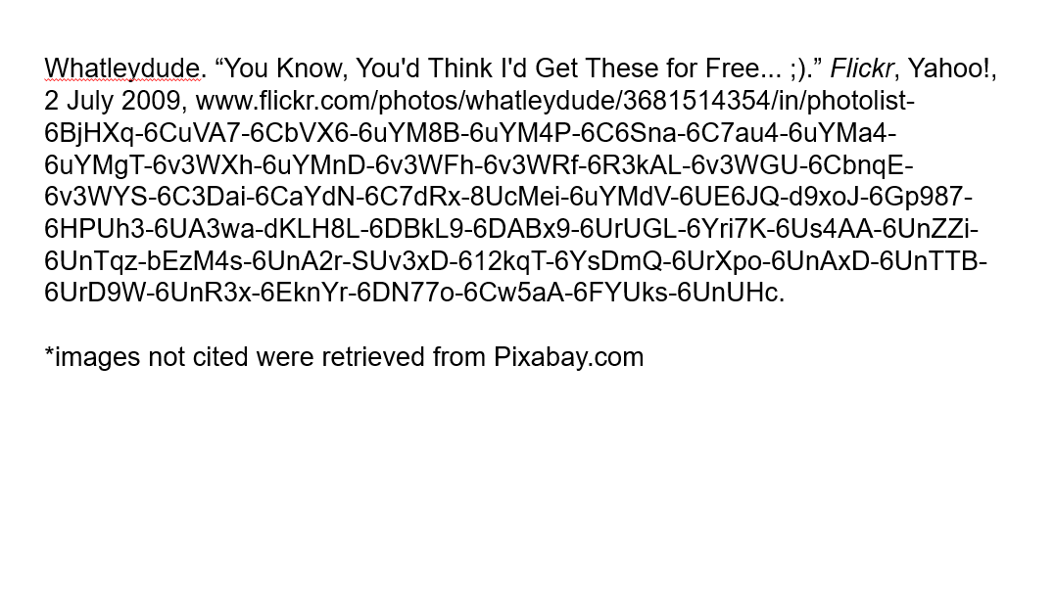

Appendix B
Caffeine Consumption Infographic

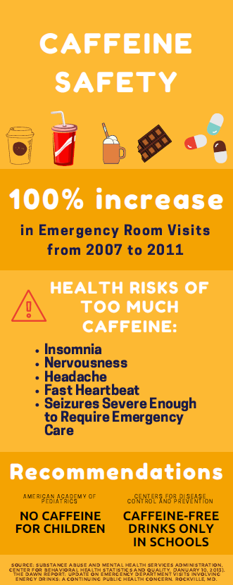

Appendix C
Sample Poster

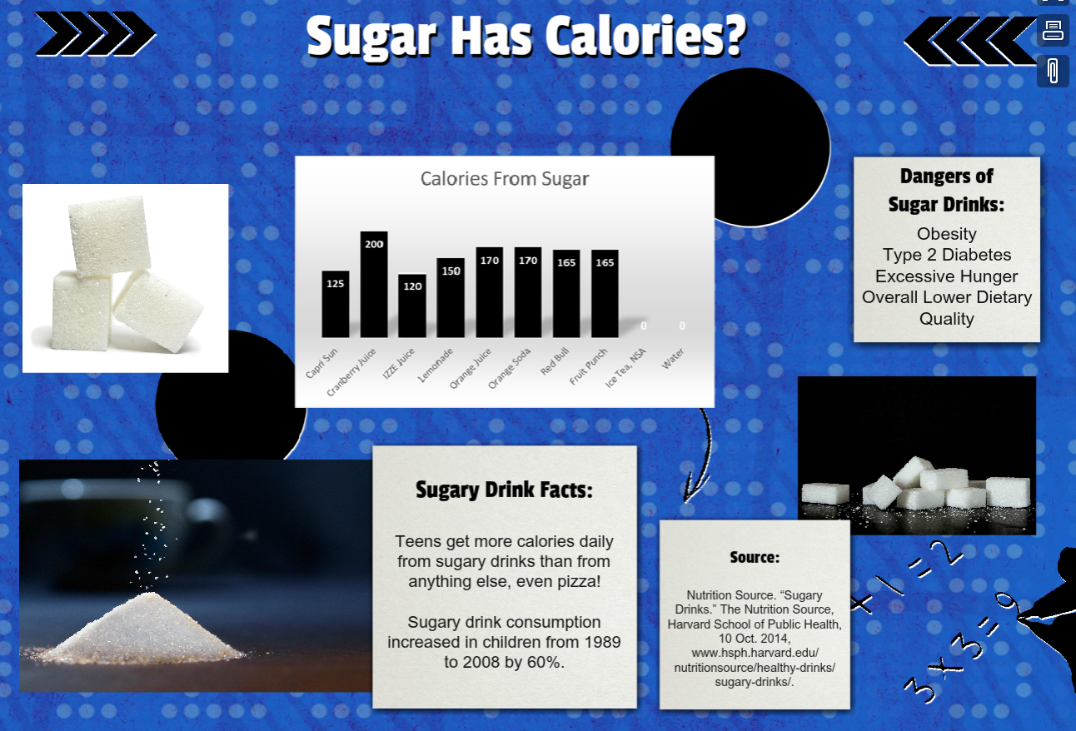

Appendix D
The Spreadsheet Lab Instructions

Caffeine: A Little Goes a Long Way

Part 1: Equal Proportions and Graphing

The Story. For today’s lab, you will do research and produce a graph to compare the caffeine content of several drinks. You will have 1.5 class periods to complete this portion of the project.

Step 1. Name a new spreadsheet “2017_12 Caffeine” and share it with crosa@mountpisgahschool.org

Step 2. Set up your spreadsheet like the example at the end of these instructions. Choose 7 seven caffeine-containing drinks to research. You may use the ones listed in the example if you’d like. Note that there are two columns that contain the names of the drinks. The reason for both columns is a limitation of Google Sheets; the second column needs to be included to create your graph.

Step 3. Name a new Google Doc “2017_12 Caffeine Sandbox.”

Step 4. On the internet, do some research to find the caffeine content in milligrams (mg) of each drink. To do your Internet search, use the website www.kiddle.co. If you start your search field with “caffeine content of …” you should be able to find all the information you need. Use your new Google Doc, “2017_12 Caffeine Sandbox,” to record data and enter citation information for every website you use in MLA8 format. Use the Purdue OWL for proper formatting.

For each drink find:

- The number of milligrams (mg) of caffeine

- The size of the container for which the data is reported. Make sure that you note the size of the container accurately. The size of the container could be given in ounces or milliliters. If your data is in ounces, you should convert that value to milliliters (mL). Simply multiply the volume given in ounces by 29.57 to get milliliters.

Again, all container sizes need to be in milliliters (mL). They don’t have to be the same size of container since you’re going to write a formula to “normalize” the containers based upon your “base” size in Step 5. Remember, normalizing is the process of comparing relationships of caffeine to volume where the volume of each container is the same (e.g. 250 mL). That’s how we can see which beverages have more caffeine than others.

Step 5. Enter your data that you have just found into the appropriate columns of your spreadsheet. If your spreadsheet is set up like mine, this will be in columns B and C.

Step 6. Write a formula to reflect the value of your normalized container size into column E (in my example, the formula is =$B$1). Using a formula allows you to change the container size in one cell rather than all 7 cells. Look at the figure to see how the result should be.

Step 7. Convert the number of milligrams of caffeine so you can compare amounts among the same size of container. For example, if your research showed that Mountain Dew has 54 mg of caffeine in a 355 mL bottle, it would have 38 mg of caffeine in a 250 mL container. Use a cross product formula to calculate the new values. In the example below, the formula is =B3*$B$1/C3 and it goes into cells E3:E8. Go ahead and program it in. If you write the formula correctly, you should be able to use the drag-and-copy feature to get it into all the cells.

Step 9. Using a formula in Sheets, calculate the average value for each column. For example, if you want to find the average value of the number in cells E3 through E8, use this formula:

=AVERAGE(E3:E8)

Step 10. Create a column chart of the data calculated in column E. Use Mr. Petitto’s video if you need a refresher on inserting charts in Google Sheets.

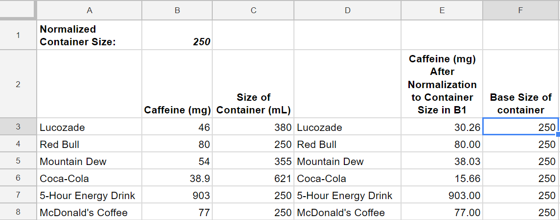

Part 2: Poster

For the second half of this three-day activity, you will work in a small group to create an eye-catching digital poster displaying the combined results of your team’s caffeine data. At a minimum, you should also include statistics on safe caffeine consumption amounts for children and adults. Use Kiddle.co to find data on caffeine recommendations. You may use the technology tool(s) of your choice (Google Doc or Slides, Glogster, Sway, etc.) to create this artifact. All sources should be cited either on the poster or in a separate Google Doc with a link on the poster. A sample poster using sugar consumption can be viewed here. This should be used as an idea of the expectation of the amount of information displayed. Your poster will look different.

Before you begin working on your poster, everyone in your group will review the elements of design found here. Use these ideas to influence your final product. In addition, follow these visual literacy guidelines:
- Use only one font type and ensure that it is clearly visible to viewers in the back of the room.
- Use contrasting colors. Avoid “rainbow” backgrounds and font colors.
- Images should only be pictures you take or those from either www.pixabay.com or www.photosforclass.com. When considering adding images, remember that “less is more.”

